**Business Requirements – Orange HRM**

**PIM Module**

This core module maintains all relevant employee related information, including different types of personal information, detailed qualifications, work experience, job related information etc. Information captured in this module is utilized by all other modules, thus eliminating data redundancy. Records can be either entered manually one by one or imported from a CSV file

**Add Employee**

A new employee is added to the system here. Other than importing details this feature allows to add an employee and define a very informative profile. To add an employee, go to PIM>>Add Employee and the screen as shown in Figure 1:

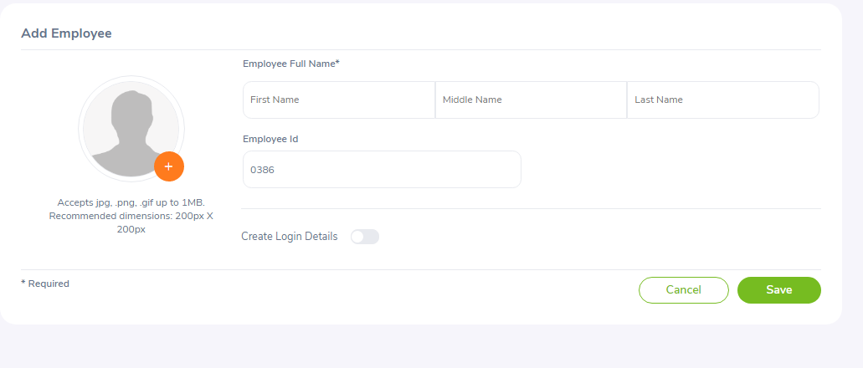

Figure 1: Add Employee

Enter the relevant fields and you may also add a picture of the employee. To add a picture, click on “+” button and select the picture from the relevant path and click “Open”. Employee code is generated automatically, but can be changed if required.

You may also create a user login for the employee through this screen.

**\*Note:** Please note that the maximum file size of the picture cannot exceed 1 megabyte.

Click “Save” once completed.

**Employee’s Personal Details**

The following information needs to be obtained from each employee to create a complete employee profile that may be used by the company. These features are explained in details as we go on.

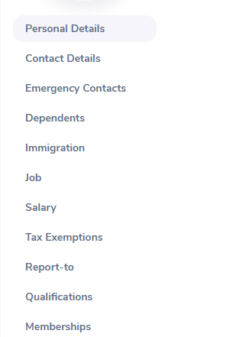

Figure 2: Employee details Column

***Personal Details***

One you have added and saved the employee name with his/her picture and the user logins, the screen as shown in Figure 3.

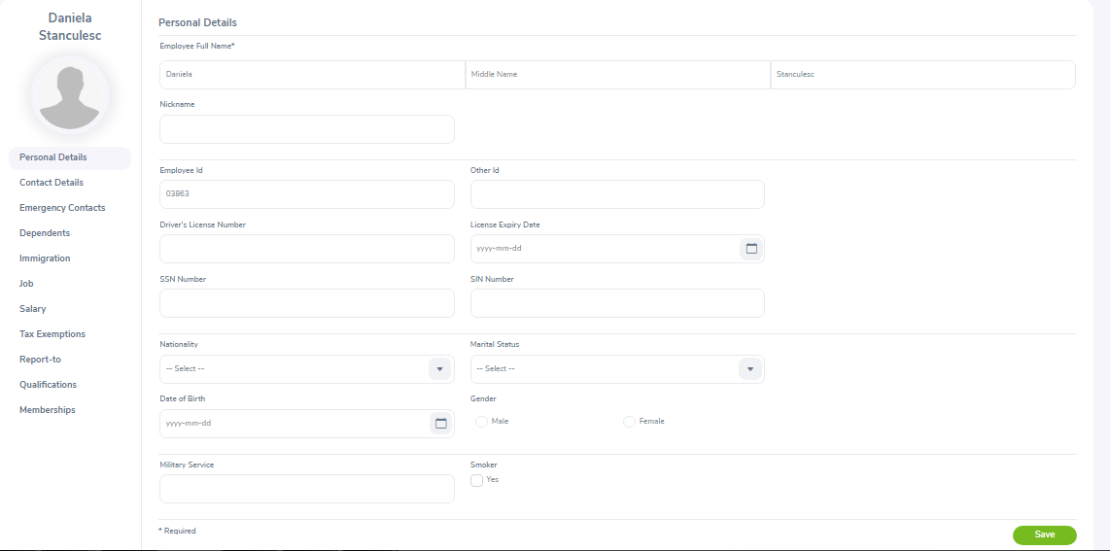

Figure 3: Personal Details

You can also edit the personal details listed. Clicks “save” once the fields are added.

You can edit the following:

- Code – Employee Id/No

- Last Name

- First Name

- Middle Name

- Nick Name

- Nationality – Select from a list of pre-defined nationalities

- Date of Birth

- Other Id

- Marital Status – Select from the drop down

- Smoker – If the employee is a smoker click on the box

- Gender – Click on the relevant gender

- Driver’s License Number

- License Expiry Date

- Military Service

Click “Save” once completed.

You may also upload any attachment that would support the details you have entered on the form by clicking “Add” under the “Attachment” and selecting a file from a relevant path and upload the following file by clicking “Upload”.

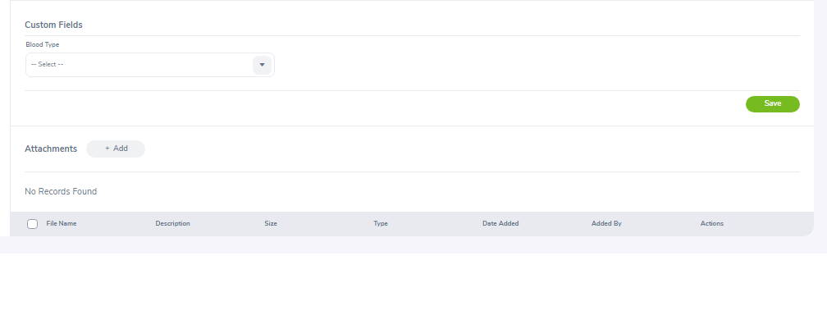

Figure 4: Custom and Attachments Field

You may upload multiple entries of supporting attachments. You may edit the following attachments by clicking “Edit” on the right hand end of a particular entry. To delete an attachment, click on the check box next to particular entry. It is also possible to delete multiple entries at the same time by clicking the check box entries you wish to delete and simply clicking “Delete”.